IMPORTANT: Hotel accommodations are the attendee’s responsibility.
Call the hotels directly for reservations or reserve your room online.

Stay close to all the action! We have secured room blocks for our group for a limited time. Reserve your room at one of the following convenient hotels. Don’t delay! After the blocks expire, we can not guarantee price or availability of hotel rooms.

Each of the following hotels have been recommended by the Bray family as safe and affordable options. Each hotel offers a generous 48-hour prior to the check-in date for cancellation without penalty.

Best Western Plus Heritage Inn

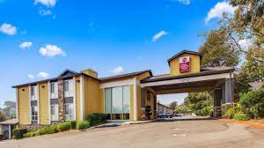
Best Western Plus Heritage Inn is a 96-guest room hotel with pool and fitness facilities. Standard room rates start at $152.19/ night for double Queen rooms, slightly more for King rooms. Taxes and fees will be added. Complimentary breakfast bar is included. All Queen rooms can accommodate up to 4 persons in a room. The hotel is located at 1955 E 2nd Street Benicia, California 94510
Ask for the “USS Indianapolis” Block. BLOCK ENDS JUNE 6, 2023. Call directly at (707) 746-0401 or use the reservation link: https://www.bestwestern.com/en_US/book/hotel-rooms.05479.html?groupId=2E4PW1I1

Holiday Inn Express
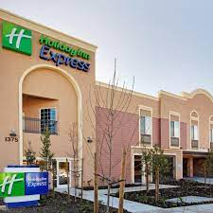

Holiday Inn Express Benicia is a 49-guest room hotel in the heart of Benicia. Room rates start at $169 per night for a King standard room, slightly more for double Queen rooms. Taxes and fees will be added. Breakfast is included. All Queen rooms can accommodate up to 4 persons in a room. The hotel is located at 1375 East 5th Street, Benicia, California 94510

Ask for the “USS Indianapolis Reunion 2022” Block. BLOCK ENDS MAY 22, 2023. Call the hotel directly at (707) 297-6873 to book or use the reservation link: https://www.hiexpress.com/redirect?path=rates&brandCode=EX&localeCode=en&regionCode=1&hotelCode=BNICA&checkInDate=06&checkInMonthYear=062023&checkOutDate=09&checkOutMonthYear=062023&_PMID=99801505&GPC=USS&cn=no&viewfullsite=true

